DESIGN AND ANALYSIS OF ALGORITHM

NAME:Ragavendar
ROLL NO:CH.SC.U4CSE24260
- QUICK SORT CODE:
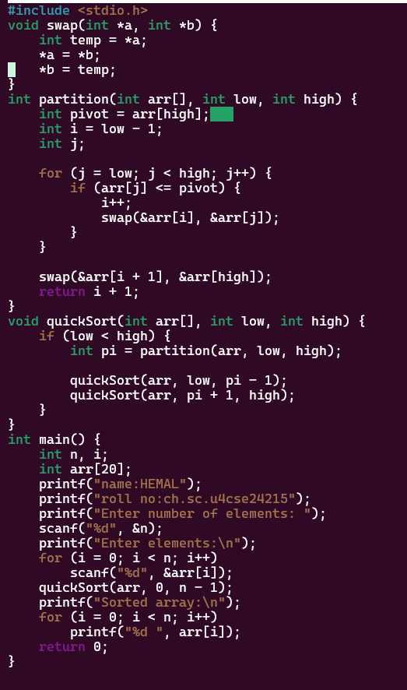

OUTPUT:

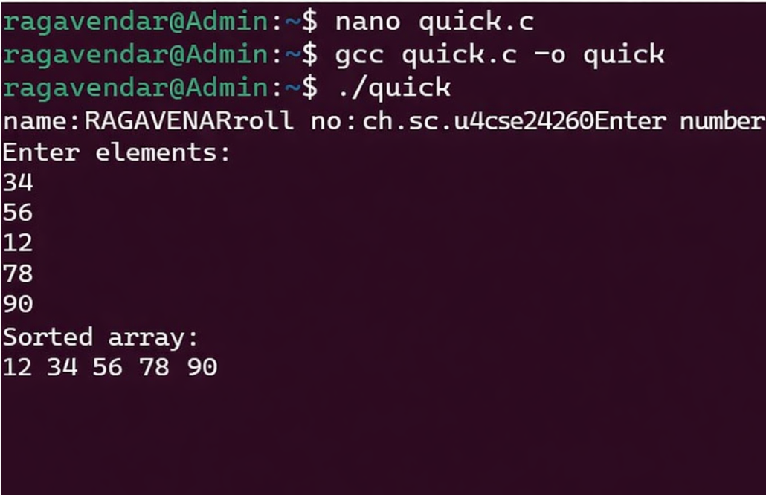

Quick Sort is a divide-and-conquer sorting algorithm
that selects a pivot element and partitions the array into two sub-arrays such that elements smaller than the
pivot are placed on the left and larger elements on the right. this process is applied recursively to sort the array efficiently.

- merge sort Code:
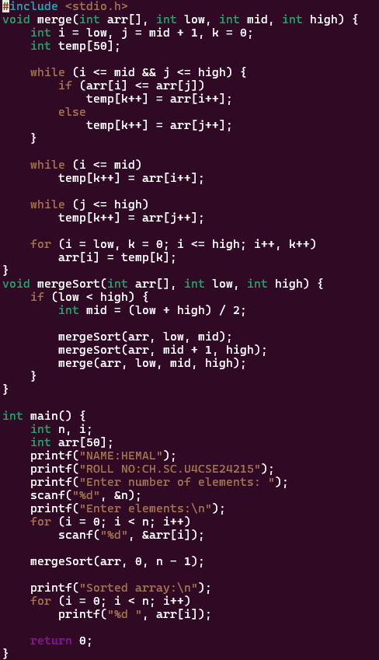

Output:

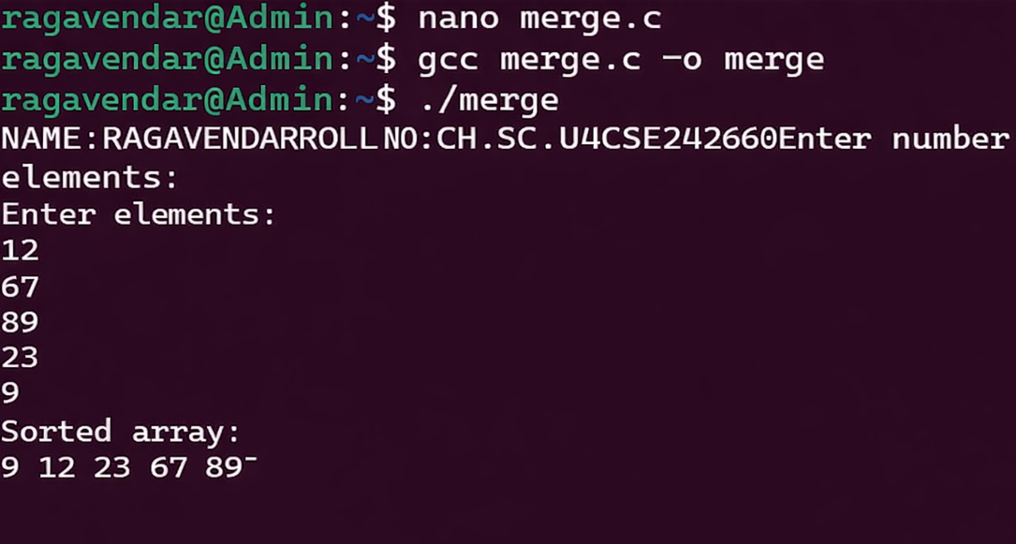

Merge Sort is a divide-and-conquer sorting algorithm that repeatedly divides the array into smaller sub-arrays until each contains a single element, and then merges these sub-arrays in sorted order to
produce the final sorted array.

- binary search tree Code:
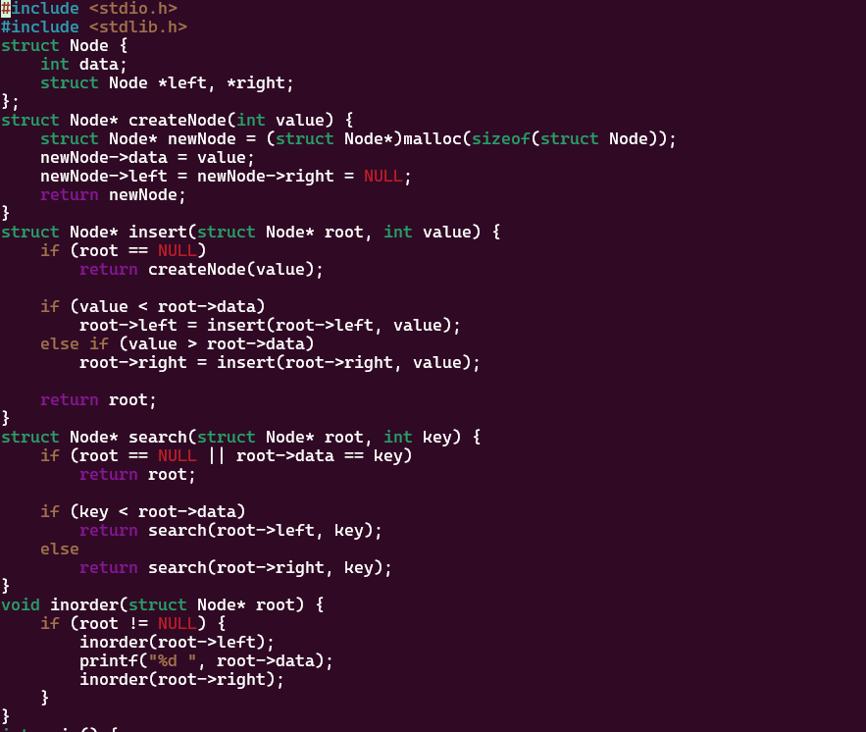

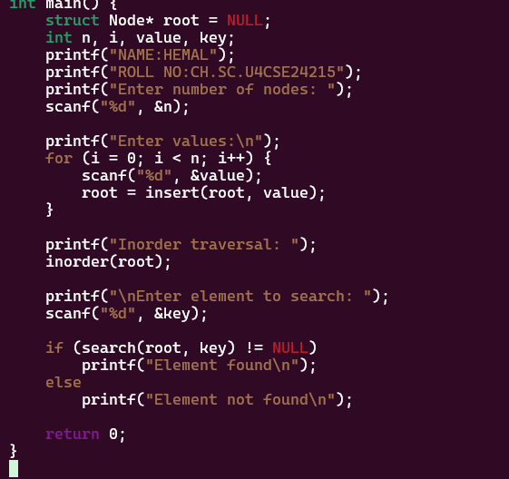

A binary search tree is a non-linear data structure in
which each node contains a value such that all values in the left subtree are smaller and all values in the right
subtree are larger. this property allows efficient searching, insertion, and traversal of elements.
